Wipro TalentNext – Database Solution Expert
Module 3: Using Sub Queries to Solve Queries

Question 1
Create a report that displays EMPNO, ENAME, DEPTNO of employees who work with that employee. (Nested Sub Query)
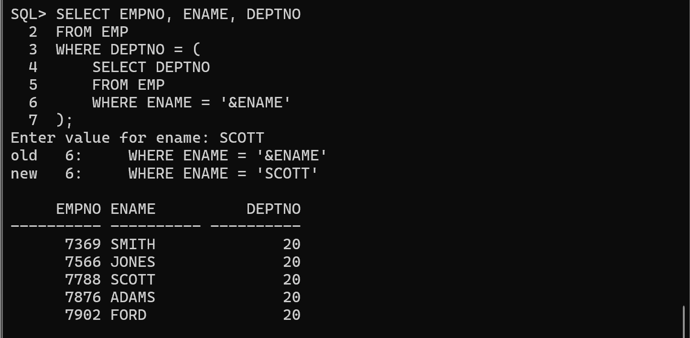
Question 2
Display the employees who earn more than the average salary of the EMP table. (Nested Sub Query)
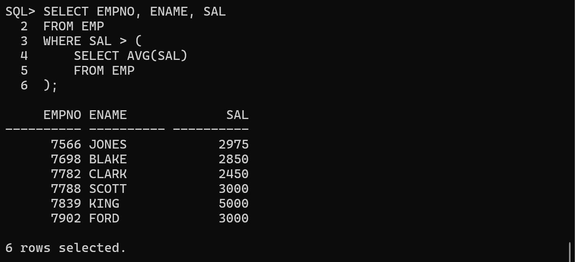
Question 3
Display the ENAME and JOB who are Managers. (Use EXISTS Operator)
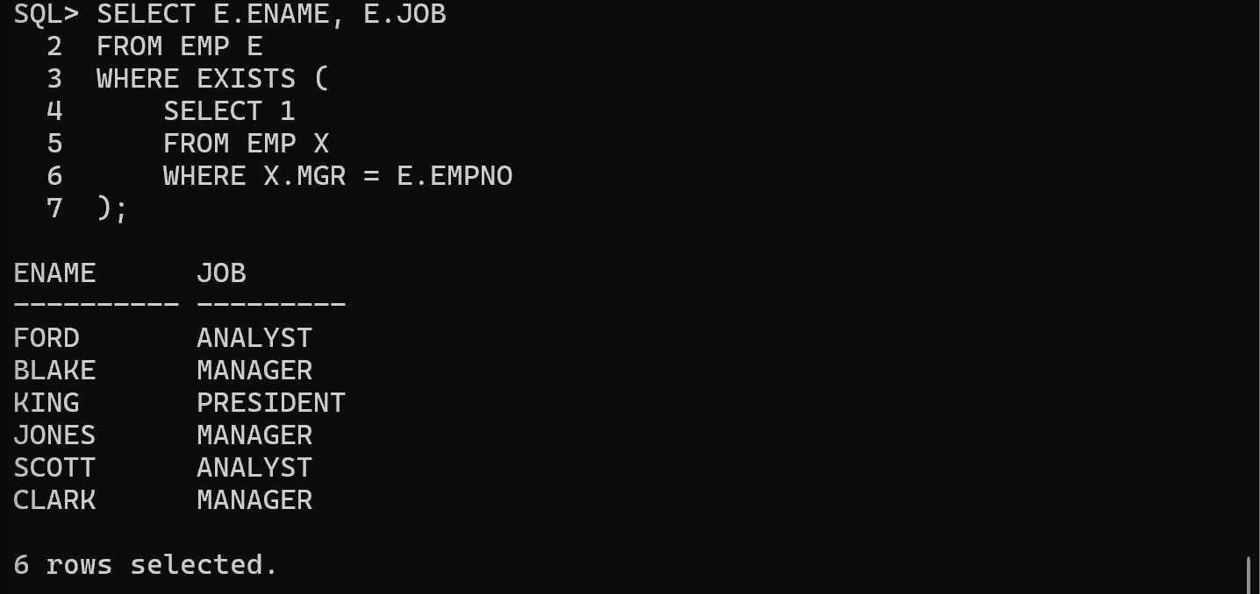
Question 4
Display the employees who earn less than the least salary of DEPTNO 10. (Use ALL operator)
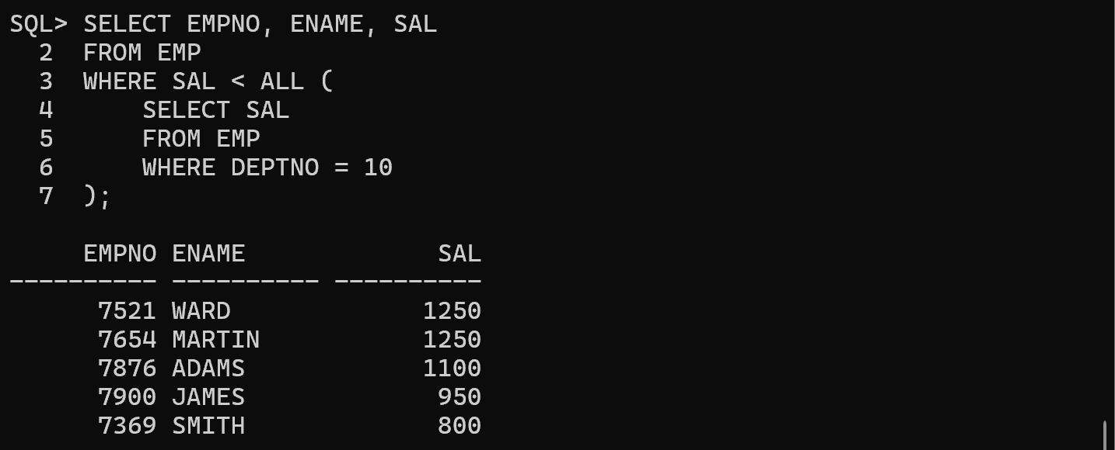
Question 5
Display the employees who have the same DEPTNO and MGR as a given employee, excluding that employee. (Use Nested Sub Query)
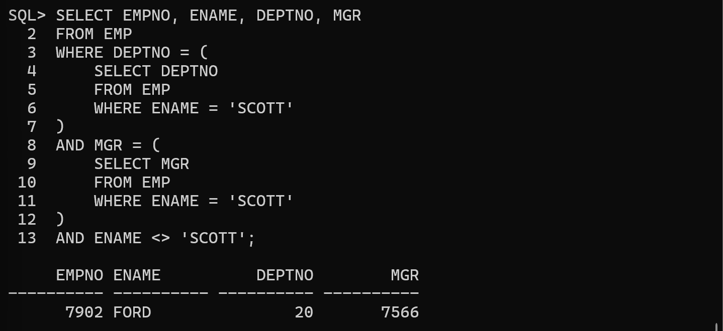
Question 6
Display the employee(s) whose salary is greater than the salary of ALL employees in Department 30. (Use the ALL operator.)
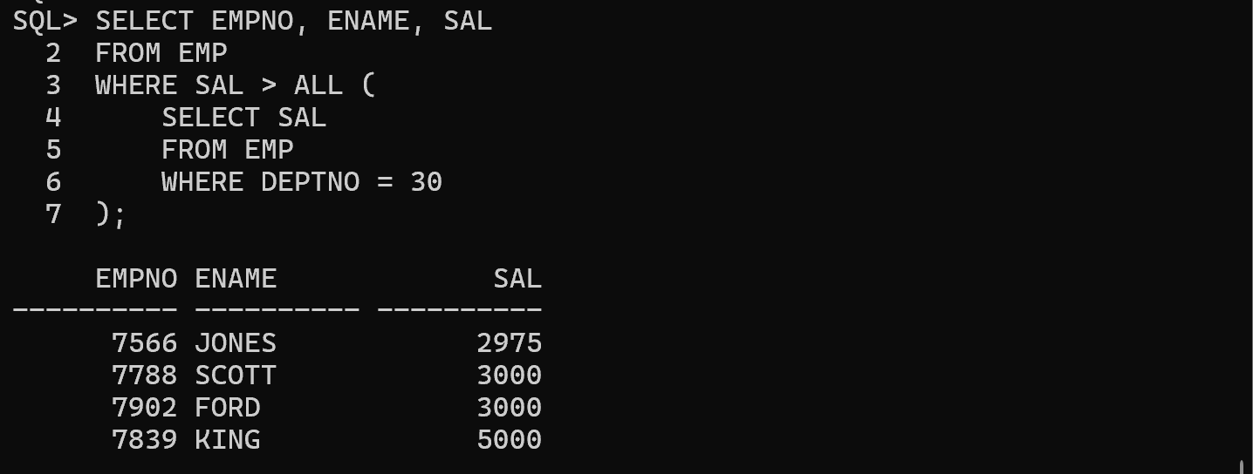
Question 7
Display the employees who work in the same department as SCOTT, excluding SCOTT. (Use a Nested Subquery.)
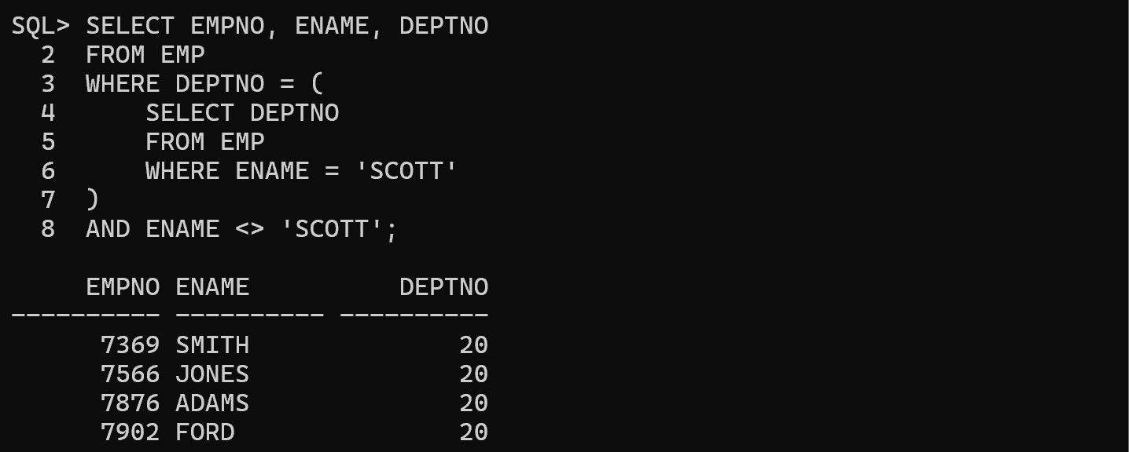

Question 8
Display the employee(s) whose salary is equal to the highest salary in the EMP table. (Use a Nested Subquery.)
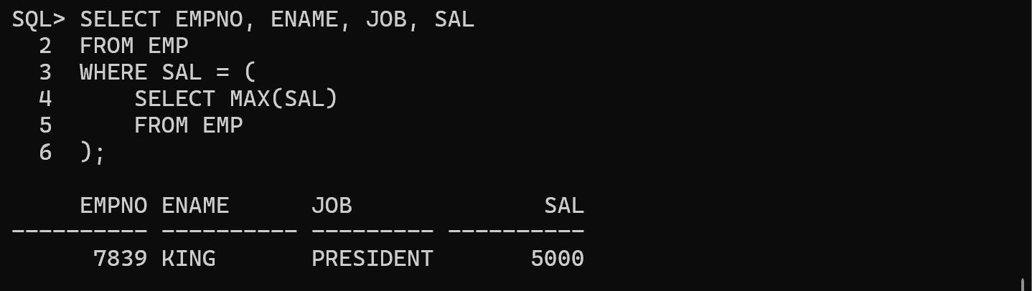
Question 9
Display the employees who are working in departments that have at least one employee with the job MANAGER. (Use the IN operator with a subquery.)
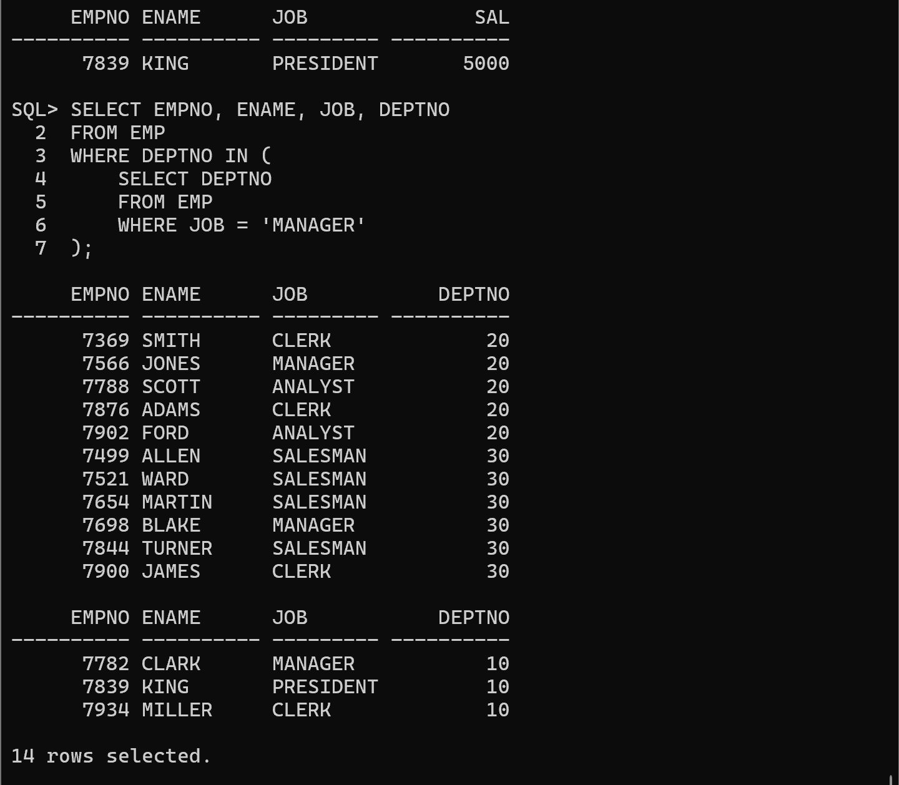 Question 10
Display the employee(s) whose salary is greater than the average salary of their own department. (Correlated Subquery)
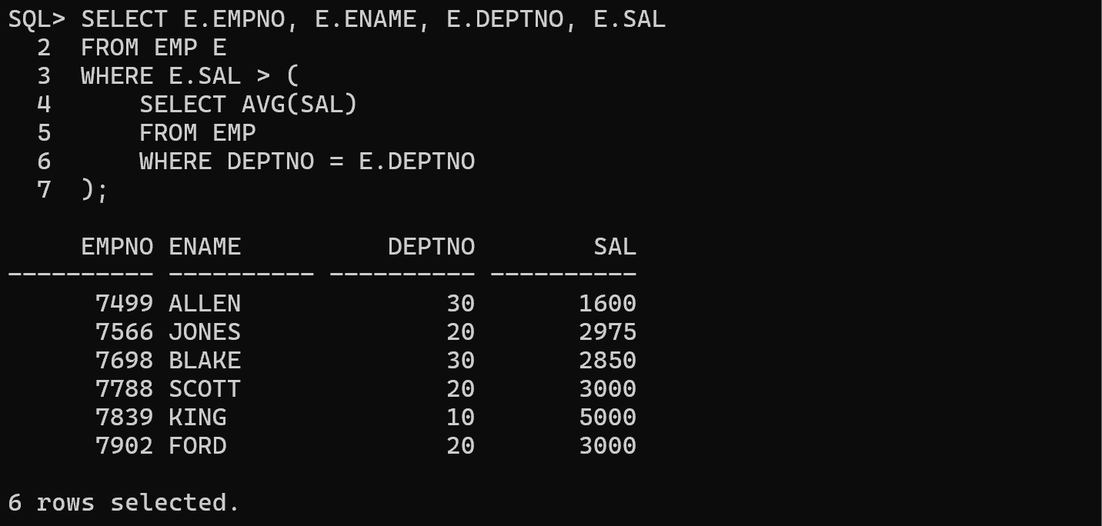
Question 11
Display the employees whose salary is the second highest in the EMP table. (Nested Subquery)
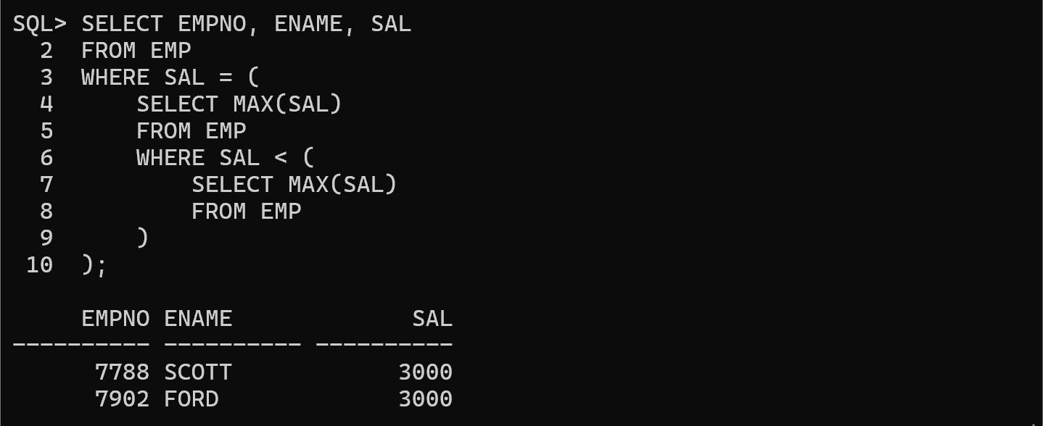
Question 12
Display the employee(s) who do not have any subordinates. (Use the NOT EXISTS operator.)
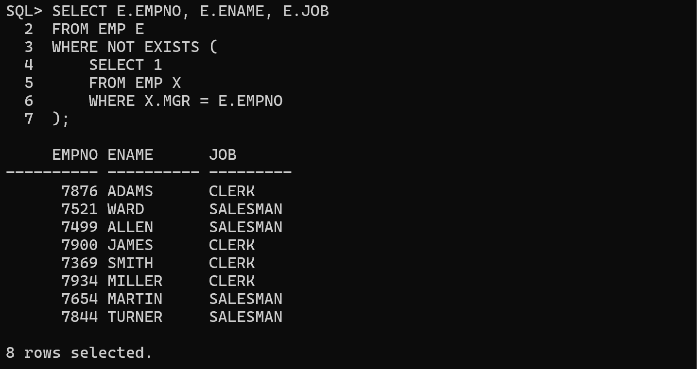 Question 13
Display the employee(s) who earn the maximum salary in each department. (Correlated Subquery)
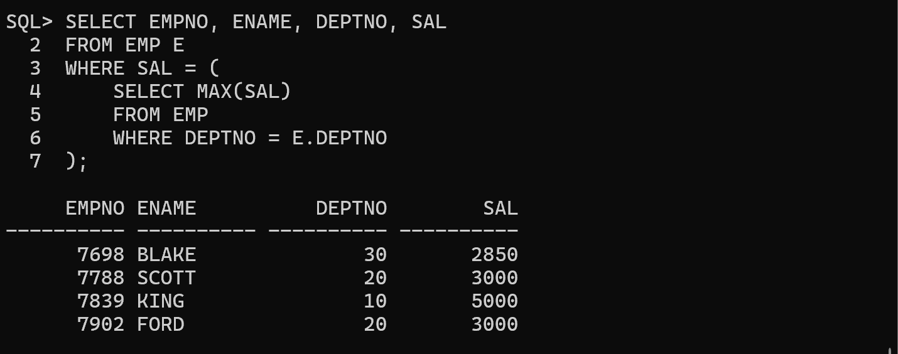
Question 14
Display the employee(s) who earn the minimum salary in each department. (Correlated Subquery)
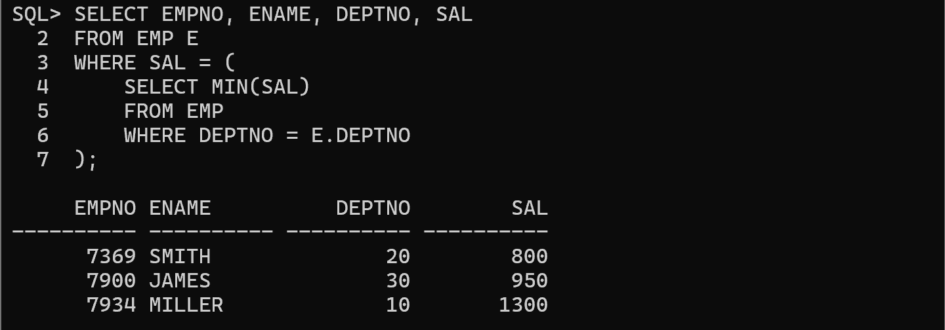
Question 15
Display the employee(s) whose salary is greater than the salary of their manager. (Correlated Subquery / Self-Join)
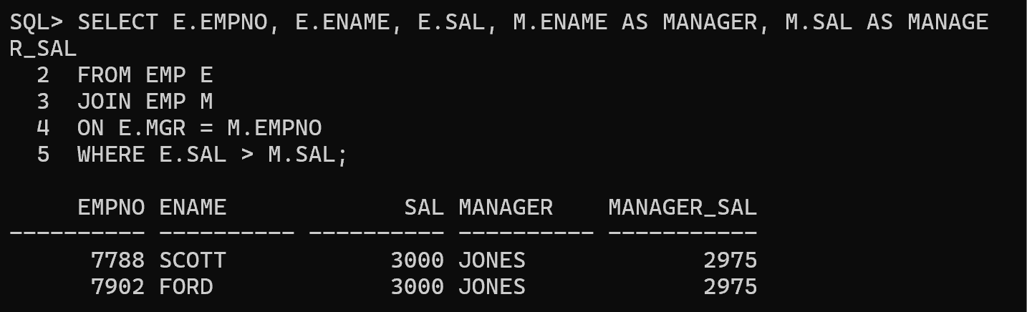
Question 16
Display the employees who earn less than the average salary of their respective department. Also display the department average. (Use Inline Views)
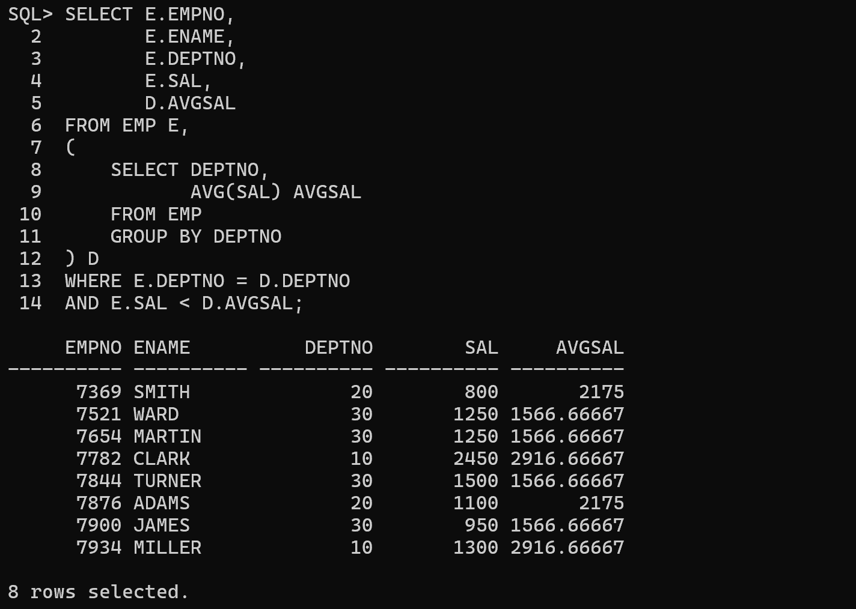
Question 17
Write a query that displays the LOC of those departments that have a sum of salaries less than the average salary of all employees. (Use WITH Clause)
